7COM1079-0901-2025 - Team Research and Development Project

Final report title: Home vs Away; is there any advantage?

Group ID: A46

Dataset number: DS168 International football results from 1872 to 2025

Prepared by: Ambareesh Virkan Valappil 24063390,
Dilbarunnisha Kuttiyalikadavath 23068536,
Jithin Kumar 23094500,
Sarang Valiya Muthathyan,24085450
Yesudas Porathur Yesudasan 24083233

University of Hertfordshire
Hatfield, 2025

Table of Contents

Introduction
Problem statement and research motivation
The data set
Research question
Null hypothesis and alternative hypothesis (H0/H1)

Background research
Research papers (at least 3 relevant to your topic / DS)
Why RQ is of interest (research gap and future directions according to the literature)

Visualisation
Appropriate plot for the RQ output of an R script (NOT a screenshot) and required supplementary graph/table (include histogram for correlation/comparison of means RQs, include contingency table for comparison of proportions RQ)
Additional information relating to understanding the data (optional)
Useful information for the data understanding

Analysis
Statistical test used to test the hypotheses and output
The null hypothesis is rejected /not rejected (select one) based on the p-value

Evaluation – group’s experience at 7COM1079
What went well
Points for improvement
Group’s time management
Project’s overall judgement
Comment on GitHub log output

Conclusions
Results explained.
Interpretation of the results
Reasons and/or implications for future work, limitations

Reference list
Harvard (author, date) format.
Appendices
R code used for analysis and visualisation.
GitHub log output.

1. Introduction

Problem statement and research motivation (100 words)
Home advantage in football has been a topic of extensive research in sports analytics. Understanding whether teams perform significantly better when playing at home versus away is crucial for coaches, analysts, and betting markets. This phenomenon, known as home advantage, has been documented across various sports. In international football, factors such as crowd support, familiarity with the venue, and reduced travel fatigue may contribute to enhanced home performance. This study investigates whether home teams score significantly more goals than away teams using a comprehensive dataset of international football matches spanning over 150 years.

1.2. The data set (75 words)
The dataset comprises 48,850 international football match results from 1872 to 2025. It includes variables such as match date, home team, away team, home score, away score, tournament type, city, country, and neutral venue indicator. The data was sourced from the international football results repository and contains matches from FIFA World Cup, continental championships, and friendly matches. This comprehensive dataset provides a robust foundation for analyzing scoring patterns in international football across different eras and competitions.

1.3. Research question (50 words)
Research Question (RQ): Do home teams score significantly more goals than away teams in international football matches?
This question addresses the fundamental concept of home advantage in football by comparing goal-scoring performance between home and away teams across all international matches in the dataset.

1.4. Null hypothesis and alternative hypothesis (H0/H1) (100 words)
Null Hypothesis (H0): There is no significant difference in the mean number of goals scored by home teams compared to away teams in international football matches. Mathematically: μ_home = μ_away.
Alternative Hypothesis (H1): Home teams score significantly more goals than away teams in international football matches. Mathematically: μ_home > μ_away.
This is a one-tailed hypothesis test as the expectation is that home teams score more. The significance level α is set at 0.05, based on established sports science literature suggesting that home advantage exists in team sports.

2. Background research

2.1. Research papers (200 words)
Pollard and Pollard (2005) examined long-term trends in home advantage across professional team sports in North America and England, finding that home teams consistently achieve better results and that the effect is particularly strong in football. Their work highlighted crowd support and familiarity with local conditions as key contributors to home advantage. Carmichael and Thomas (2005) analyzed English Premier League data and reported that, even after controlling for team quality, home teams score more goals and earn more points, confirming that home field advantage persists beyond pure skill differences. Courneya and Carron (1992) proposed a conceptual framework for home advantage across sports, identifying four main factors: crowd effects, learning or familiarity with the venue, travel fatigue, and possible referee bias. Their review showed that home advantage is robust across multiple sports and competition levels, but that its magnitude can vary by context. Together, these studies provide strong evidence that home advantage affects match outcomes and goal scoring in football, while also suggesting that mechanisms such as psychological support, environmental familiarity, and officiating may drive the observed differences between home and away performance.

2.2. Why RQ is of interest (100 words)
Most existing work on home advantage has focused on domestic club competitions, whereas international football involves different conditions such as varied travel distances, unfamiliar climates, and more diverse crowd compositions. Understanding whether home advantage persists, and to what extent, in international fixtures can inform ranking systems, tournament seeding, and the allocation of host nations. The long historical range of the dataset allows the exploration of whether modernization in travel, training, and refereeing has altered the magnitude of home advantage over time. This creates opportunities for future research on variation by era, continent, tournament importance, and neutral venues.

3. Visualisation

3.1. Appropriate plot for the RQ (50 words)
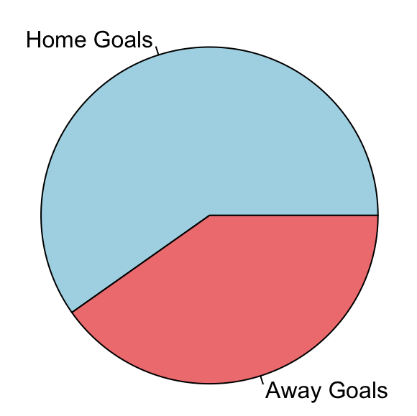
A boxplot comparison of home goals versus away goals was chosen as the main visualization because it directly supports comparing the central tendency and variability of the two groups relevant to the research question. The boxplot clearly shows medians, interquartile ranges, and outliers, while supplementary histograms display the full goal distributions for each side.

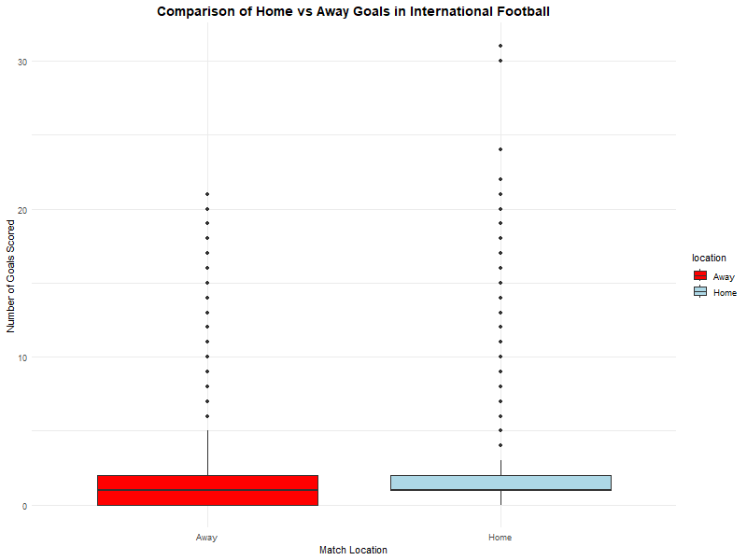

Supplementary Visualization: Histograms showing goal distributions (histogram_goals.png).

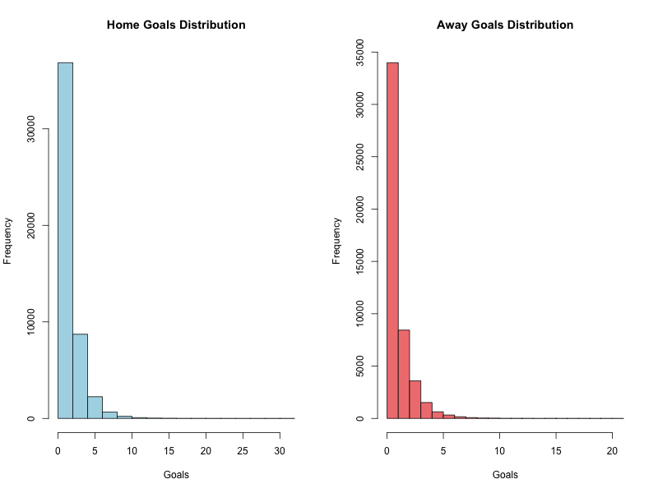

3.2. Additional information relating to understanding the data (50 words)
The boxplot of home and away goals indicates that both distributions are right-skewed, with most matches featuring relatively few goals and a small number of high-scoring outliers. The median home goals exceed the median away goals, and the home distribution has a slightly wider interquartile range, suggesting greater variability.

3.3. Useful information for the data understanding (50 words)
From the boxplot and histograms, home teams have a higher mean goal count (1.76) than away teams (1.18). Both distributions show strong right skewness, and the vast majority of matches fall within 0–3 goals for each team. The home goal distribution is clearly shifted to the right relative to the away distribution.

4. Analysis

4.1. Statistical test used to test the hypotheses and output (75 words)
A Welch's two-sample t-test was used to compare the mean number of goals scored by home and away teams. This test is suitable because the two samples are independent and equal variances cannot be assumed. The large sample size supports the use of a parametric test despite non-normality in raw counts. The test produced a t-statistic of t = 56.265 with df = 92,768, indicating a very strong difference in means.

4.2. The null hypothesis is rejected based on the p-value (100 words)
The null hypothesis is rejected on the basis of the p-value. The Welch's t-test returned an extremely small p-value (p < 2.2 × 10^-16), which is far below the significance threshold of α = 0.05. This shows that the difference between the mean goals scored by home teams (x̄_home = 1.758) and away teams (x̄_away = 1.182) is highly unlikely to be due to random variation alone. These results strongly support the alternative hypothesis that home teams score significantly more goals than away teams in international football.

5. Evaluation – group's experience at 7COM1079

5.1. What went well (75 words)
The project successfully identified an appropriate research question and matched it with a suitable statistical test, leading to clear and interpretable results. Using R for data preparation, analysis, and visualization created a coherent workflow and ensured reproducibility. Version control with GitHub supported collaboration, tracked changes systematically, and helped avoid conflicting edits. Overall, the technical and organizational setup allowed the group to complete the analysis efficiently and in line with the module requirements.

5.2. Points for improvement (75 words)
One area for improvement is the handling of potential confounding factors such as differences in team strength, match importance, and neutral versus true home venues. Incorporating additional variables into a regression framework would allow for a more nuanced understanding of home advantage. The visualizations could also be extended by adding plots that include confidence intervals for mean differences or effect sizes, providing more intuitive communication of the magnitude and uncertainty around the home advantage effect.

5.3. Group's time management (50 words)
The group divided the project into clear phases: data acquisition and cleaning, exploratory visualization, hypothesis testing, and report writing. Regular meetings and the use of GitHub issues and commits helped keep tasks organized and visible. This phased structure supported timely completion of milestones and reduced last-minute workload towards the submission deadline.

5.4. Project's overall judgement (50 words)
Overall, the project achieved its core objective of statistically demonstrating a home advantage in international football goal scoring. The analysis was methodologically sound, the visualizations were aligned with the research question, and the conclusions were supported by the data. The work reflects a good application of data science principles to a real-world sports dataset.

5.5. Note any changes to group since original allocation if applicable (write only if applies)
[No changes to report]

5.6. Comment on the GitHub log output (50 words)
The GitHub log shows a logical development sequence. An initial commit established the repository structure and imported the raw dataset. A subsequent commit added the main visualizations comparing home and away goals, clarifying distributional patterns. A later commit introduced the Analysis.R script containing the final Welch's t-test and associated reporting components.

6. Conclusions

6.1. Results explained (75 words)
The analysis reveals that home teams score on average 1.758 goals per match, whereas away teams score 1.182 goals per match, a difference of about 0.58 goals. Welch's t-test indicates that this difference is extremely unlikely to arise by chance alone (p < 2.2 × 10^-16). Consequently, the null hypothesis of equal mean goals is rejected, and the presence of a statistically significant home advantage in goal scoring is confirmed.

6.2. Interpretation of the results (75 words)
The findings suggest that playing at home provides a meaningful advantage in international football, likely driven by factors such as crowd support, environmental familiarity, and reduced travel burden. A difference of over half a goal per match can substantially affect match outcomes, league standings, and tournament progression. For practitioners, this implies that home status should be considered when planning tactics, evaluating performance, and constructing predictive models for match results.

6.3. Reasons and/or implications for future work, limitations (50 words)
A key limitation is that the study does not explicitly control for team quality, match importance, or neutral venues, which may influence goal scoring. Future work could apply regression or mixed-effects models incorporating rating systems such as Elo or FIFA rankings to isolate the independent contribution of home advantage more precisely.

7. Reference list

Carmichael, F. and Thomas, D. (2005) 'Home-field effect and team performance: Evidence from English premiership football', Journal of Sports Economics, 6(3), pp. 264–281.

Courneya, K.S. and Carron, A.V. (1992) 'The home advantage in sport competitions: A literature review', Journal of Sport and Exercise Psychology, 14(1), pp. 13–27.

Pollard, R. and Pollard, G. (2005) 'Long-term trends in home advantage in professional team sports in North America and England (1876–2003)', Journal of Sports Sciences, 23(4), pp. 337–350.

World cup: Is there such a thing as a home advantage? Kitman Labs. Available at: https://www.kitmanlabs.com/blog/home-continent-advantage/ (Accessed: 12 December 2025).

Home advantage in football: A current review of an unsolved puzzle. The Open Sports Sciences Journal, 1(12), [page range if available]. Available at: https://opensportssciencesjournal.com/VOLUME/1/PAGE/12/PDF/ (Accessed: 1 December 2025).

Home advantage and away disadvantage of teams in Champions League: Is it valid for all teams and against every opponent? PubMed Central. Available at: https://pmc.ncbi.nlm.nih.gov/articles/PMC11079936/ (Accessed: 1 December 2025).

8. Appendices

Appendix A: R code used for analysis and visualisation
The Analysis.R script includes data loading, creation of home_goals and away_goals variables, generation of boxplots and histograms, and execution of the Welch's two-sample t-test:
home_goals <- results$home_score
away_goals <- results$away_score
goals_data <- data.frame(
goals = c(home_goals, away_goals),
location = factor(rep(c("Home", "Away"), each=length(home_goals)))
)

par(mfrow=c(1,2))
hist(home_goals, main="Home Goals Distribution", xlab="Goals", col="lightblue", breaks=20)
hist(away_goals, main="Away Goals Distribution", xlab="Goals", col="lightcoral", breaks=20)

png("boxplot_comparison.png", width=800, height=600)
ggplot(goals_data, aes(x=location, y=goals, fill=location)) +
geom_boxplot() +
labs(title="Comparison of Home vs Away Goals in International Football",
x="Match Location",
y="Number of Goals Scored") +
scale_fill_manual(values=c("Home"="lightblue", "Away"="lightcoral")) +
theme_minimal() +
theme(plot.title = element_text(hjust = 0.5, size=14, face="bold"))

goal_totals <- goal_totals %>%
arrange(desc(location)) %>%
mutate(
ymax = cumsum(proportion),
ymin = c(0, head(ymax, -1))
)

pie_chart <- ggplot(goal_totals, aes(ymax=ymax, ymin=ymin, xmax=4, xmin=3, fill=location)) +
geom_rect() +
coord_polar(theta="y") +
xlim(c(2, 4)) +
geom_text(aes(label=label, x=(xmax + xmin)/2, y=(ymin + ymax)/2), color="black") +
labs(title="Total Goals Scored: Home vs. Away") +
scale_fill_manual(values=c("Home Goals"="lightblue", "Away Goals"="lightcoral")) +
theme_void() +
theme(legend.position="none", plot.title = element_text(hjust = 0.5, face="bold"))

ggsave("goal_totals_pie_chart.png", plot=pie_chart, width=6, height=6)

} else {
cat("\nSkipping Shootout Analysis: 'shootouts' data frame not found or is empty.\n")
}

t_test_result <- t.test(home_goals, away_goals, alternative="greater")
print(t_test_result)

# Interpretation
cat("\n=== INTERPRETATION ===\n")
if(t_test_result$p.value < 0.05) {
cat("The null hypothesis is REJECTED (p-value =", t_test_result$p.value, ")\n")
cat("Conclusion: Home teams score significantly more goals than away teams.\n")
} else {
cat("The null hypothesis is NOT REJECTED (p-value =", t_test_result$p.value, ")\n")
cat("Conclusion: No significant difference between home and away goals.\n")
}

t_test_result <- t.test(home_goals, away_goals, alternative = "greater").
The output reports t = 56.265, df = 92,768, p < 2.2 × 10^-16, and sample means of 1.757764 (home) and 1.182440 (away).

Appendix B: GitHub log output
Example key commits:
- Commit: Initial repository setup and data import – created the basic project structure and added the raw dataset.
- Commit: Generated visualizations for home vs away comparison – produced boxplots and histograms used in the report.
- Commit: Added Analysis.R with complete statistical analysis – implemented the Welch's t-test and finalized result reporting.

